**OT10 Major Exilic Prophets: Ezekiel, Daniel**

Dr. Marvin J. Effa

**Ezekiel**

**Author**: Ezekiel, a priest, was the author. He was taken by Nebuchadnezzar to Babylon in 597 BC. He prophesied for at least 22 years.

**Date of writing:** 592-570 B.C.

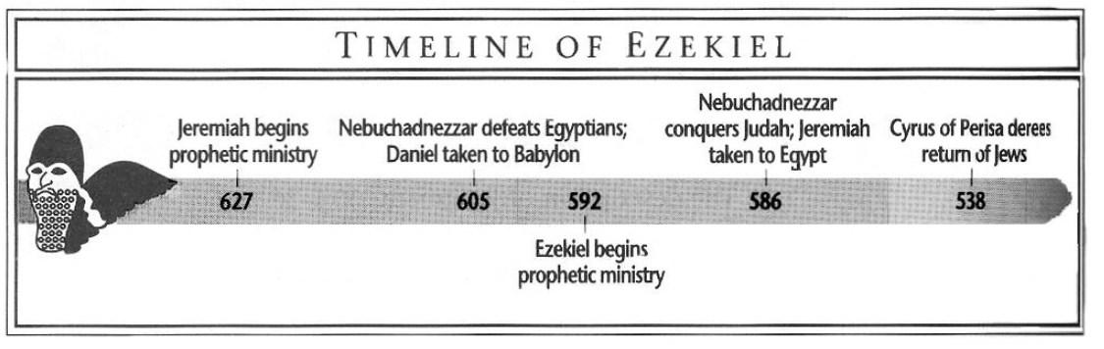

**Purpose**: to prove to the captives that God was justified in withdrawing His glory from Israel, but their punishment would not annul the glory of God in the age to come.

**Idea**: God is just in punishing Judah and the nations, but He will restore Israel to a glorious kingdom.

**Development (major blocks followed by detailed chronological outline):**

Ezekiel primarily follows a chronological development in his book.

1. Judgment on Judah (chaps. 1–24)
2. Judgment on Gentile Nations (chaps. 25–32)
3. Blessings on Israel (chaps. 33–48)[1]

**Chronological Outline of Ezekiel**

Fall of Jerusalem, July 18, 586

News of fall reached Ezekiel, January 9, 585

1. **July 31, 593**, Ezekiel 1:1-7:27.
   1. Four living creatures, Ezekiel 1.
   2. Ezekiel’s ministry, Ezekiel 2-3.
   3. Judgement on Israel, Ezekiel 4-7.
2. **September 17, 592**, Ezekiel 8:1-19:14
   1. Idolatry by leadership in the temple, Ezekiel 8.
   2. Beginning of the departure of God, Ezekiel 9.
   3. God at the threshold of the temple, then the east gate of the temple, Ezekiel 10.
   4. Death of Pelatiah; God to the middle of Jerusalem, Ezekiel 11.
   5. Prophecy of captivity and desolation, Ezekiel 12.
   6. Prophecy against false prophets, Ezekiel 13.
   7. Revelation of false elders and their idolatry, Ezekiel 14-15.
   8. Prophecy of Israel’s origin, salvation, sin, judgement, and restoration, Ezekiel 16.
   9. Parable of the two eagles and sour grapes, Ezekiel 17-18.
   10. Lamentation for leaders, Ezekiel 19.
3. **August 14, 591**, Ezekiel 20:1-28:26.
   1. History, prophecy, and judgment of Israel, Ezekiel 20-22.
   2. Parable of two sisters, Ezekiel 23.
   3. Parable of the boiling pot, Ezekiel 24.
   4. Judgment on the nations: Ammon, Moab, Edom, Philistia, Tyre, Ezekiel 23-28.
4. **January 5, 587**, Ezekiel 29:1-30:26.
   1. Judgement on Egypt, Ezekiel 29-30.
   2. **June 21, 587**, Ezekiel 31:1-18, comparison of Egypt to Assyria.
5. **March 3, 585**, Ezekiel 32:1-16.
   1. Lamentation over Egypt.
6. **March 17, 585**, Ezekiel 32:17-39:29
   1. Wailing over nations’ destruction, 32:17-32.
   2. Ezekiel is a watchman (news of Jerusalem’s fall reaches him), Ezekiel 33.
   3. False and true shepherds, Ezekiel 34.
   4. Edom’s complete destruction at the end, Ezekiel 35.
   5. Israel’s salvation and the New Covenant, Ezekiel 36.
   6. Two stage return; one nation not two, Ezekiel 37.
   7. Northern invasion, Ezekiel 38-39.
7. **April 28, 573**, Ezekiel 40:1-48:35.
   1. The Millennial Temple, Ezekiel 40-43.
   2. Service and worship in the temple, Ezekiel 44-46.
   3. Topographical changes and tribal divisions, Ezekiel 47-48.

**Key Passage Exegesis**

* The glory of God departed from the temple, Ezekiel 9:3, 10:4, 18-19, and 11:22-23.
* The king of Tyre, Ezekiel 28:11-19.
* The regathering of Israel in two parts, Ezekiel 37.
* The northern invasion, Ezekiel 38-39.
* The Millennial Temple, Ezekiel 40-48.

**Daniel**

**Author**: Daniel, cf. Daniel 12:4 where Daniel is told to seal the book.

**Date of writing:** In 605 BC Daniel was taken with the captives to Babylon and continued to minister until after Cyrus captured Babylon in 538 BC.

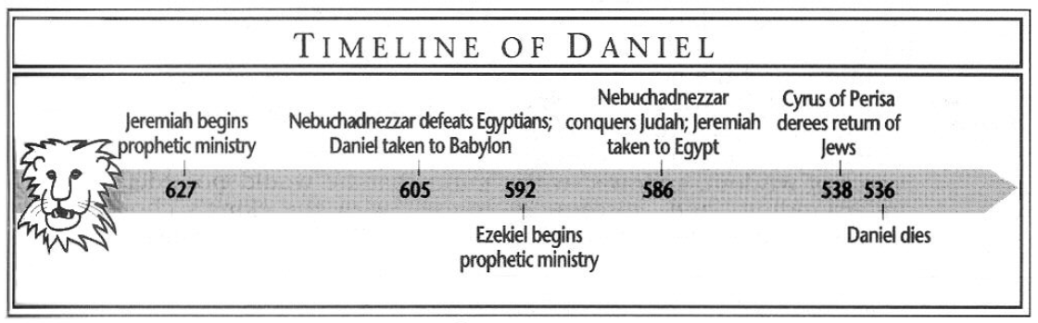

**Purpose**: to provide survival instructions for Jewish believers during the “Times of the Gentiles.”

**Idea**: Do not abandon Jewish distinctiveness because after an easily recognizable, blasphemous, global ruler is destroyed without human means, the Son of Man will receive an everlasting kingdom for Himself and His saints.

**Development:**

How believing Jews can survive during the “Times of the Gentiles:”

1. Maintain Jewish distinctiveness during the “Times of the Gentiles,” chapter 1.
2. Recognize the significance of God’s plan for world empires that will rule over Israel, chapters 2-7.
   1. The plan, part I, from a man’s perspective. The four sequential empires conclude with 10 kings and are destroyed and replaced by an eternal kingdom not established by man, chapter 2.
      1. God is able to deliver from certain death, so do not worship Gentile idols, chapter 3.
      2. God is able to convert the most autocratic ruler because His kingdom rules over men’s kingdoms, chapter 4
      3. God is able to remove foolish kings because His kingdom rules over men’s kingdoms, chapter 5.
      4. God is able to protect His own in kingdoms governed by laws rather than a king because His kingdom rules over men’s kingdoms, chapter 6.
   2. The plan, part II, from God’s perspective. After the 10 kings are ruling the world, another king dominates the world and persecutes the saints for 3 ½ years; he will be defeated by the Son of Man who will give an everlasting kingdom to His saints, chapter 7.
3. Watch for a fierce, evil king who fights the Prince of Princes but will be destroyed without human help. He is similar to a Grecian ruler of the east and south who also oppressed Israel, chapter 8.
4. Understand the “Times of the Gentiles” is limited to 490 years: Cyrus to Messiah—483 years, and the oppressing prince—7 year, chapter 9.
5. Remember that God rules the details of history, including:
   1. the vile, Grecian ruler,
   2. the blasphemous king of the north who troubles Israel as never before,
   3. the resurrections, and
   4. the conclusion of human rule on the earth, chapters 10-12.

**Key Passage Exegesis**

* The sequential world Gentile empires before Christ’s kingdom, Daniel 7.
* The time determined for Israel, Daniel 9.

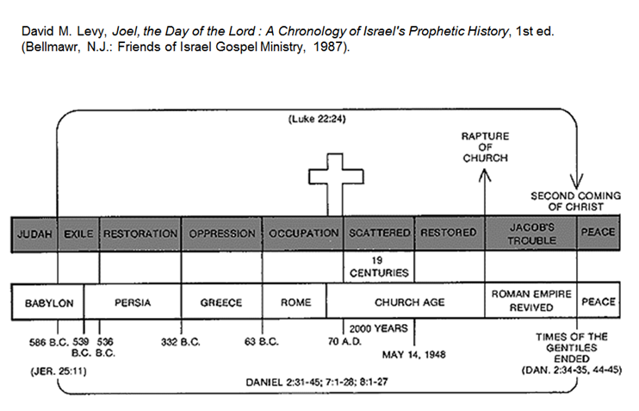

1. Dyer, C. H. (1985). Ezekiel. In J. F. Walvoord & R. B. Zuck (Eds.), *The Bible Knowledge Commentary: An Exposition of the Scriptures* (Vol. 1, pp. 1226–1227). Wheaton, IL: Victor Books.